**WASTE MANAGEMENT**

**MOBILE APP**

**PREPARED BY:**   
  
**Group Name: GROUP 26**

24/U/17380/PSA 2400717380 Muwando Mark Alvin

24/U/24852/PSA 2400724852 Wamukolo Timothy Ramon

24/U/14437/PS 2400714437 Atwijukire Anna Prudence

24/U/24330/PS 2400724330 Mwizerwa Timothy

**Mentor: MR. DENISH  
  
Course: CSC 1304 PRACTICAL SKILLS DEVELOPMENT**

**Date: 29TH AUGUST, 2025**

**Table of Contents**

Abstract 2

1.0 Introduction 3

1.1 User Challenge 3

1.2 Project Goals 4

1.3 Functional Requirements 4

2.0 Project Results 5

2.1 Product Design 5

System Architecture 6

2.2 Product Functionality and Screenshots 6

2.3 Project Website and Repository 8

3.0 Limitations and Next Steps 8

3.1 Limitations 8

3.2 Next Steps 8

References 9

Project Work Flow Diagram 10

Team Member 11

Contribution 11

# Abstract

The Waste Management Mobile App is a solution developed to combat the growing issue of poor waste disposal and inefficient recycling in many communities. The app allows users to schedule pickups, sort and sell recyclable materials, and make mobile payments seamlessly. Through integration with Firebase, Google Maps, and mobile money APIs, the platform connects households, collectors, and recyclers in a user-friendly, scalable manner. By offering features like real-time collector tracking, mobile payments, and a recyclables marketplace, the app seeks to improve community hygiene and reduce landfill waste. The technical implementation combines Flutter for the frontend and Firebase for backend services, creating a scalable and efficient solution for waste management challenges.

# 1.0 Introduction

This document outlines the development, structure, and functionality of the Waste Management Mobile App created by Group 26. The mobile app was designed as a practical response to the pressing issue of unmanaged waste in many communities, particularly in urban and peri-urban areas. Inefficient collection systems, poor recycling practices, and low public awareness have contributed to environmental degradation and public health hazards.

The Waste Management App empowers individuals to take responsibility for their waste through a digital platform that connects waste generators, collectors, and recyclers. It aims to modernize waste handling using mobile and web technologies, with a user-friendly interface built on Flutter and a robust backend powered by Firebase. By providing tools for scheduling pickups, tracking collection, selling recyclables, and making payments, the app is a step toward smarter cities and greener communities.

## 1.1 User Challenge

Many communities face challenges such as irregular waste collection, unregulated dumping, and a general lack of motivation to sort and recycle. Recycling companies also face difficulties in accessing clean and categorized recyclable materials. These gaps lead to environmental hazards, blocked drainage systems, and missed economic opportunities from waste resale.

The lack of real-time communication between waste generators and collectors results in missed pickups and unaccounted garbage accumulation. Furthermore, existing mobile waste solutions are either too expensive, lack local customization, or do not offer features like mobile payments or recycling marketplaces.

## 1.2 Project Goals

The project aims to bridge the gap between waste generators and recyclers through a streamlined, tech-driven solution. Our main goals include:

* Empower users to schedule timely and reliable waste pickups.
* Provide a user-driven marketplace to buy and sell sorted recyclables.
* Enable real-time GPS tracking of collectors via Google Maps.
* Integrate secure mobile payment features through common local platforms such as MTN and Airtel.
* Encourage environmentally responsible habits through digital incentives and gamified features.

## 1.3 Functional Requirements

The app includes the following main functionalities:  
  
The Waste Management Mobile App includes the following key features:

1. **Authentication**
   * Firebase-powered registration and login using email and password.
   * Secure user data storage with Firestore.
2. **Waste Pickup Scheduling**
   * Users can select preferred pickup date and time.
   * Location tracking helps collectors find users’ exact positions.
   * Users receive confirmation once a collector is assigned.
3. **Recyclables Marketplace**
   * Users can upload recyclables (e.g., plastic, metal) with photos and quantity.
   * Collectors or buyers view available listings and contact sellers.
   * Marketplace can be filtered by material type or price.
4. **Mobile Payments**
   * Integration with MTN and Airtel Money (currently simulated).
   * Payment confirmation and transaction history stored securely.
   * Future updates will allow in-app balance and QR-based payment.
5. **Real-time Maps and Navigation**
   * Google Maps API integrated for route tracking.
   * Collectors can navigate efficiently to each pickup location.
   * Users can view estimated time of arrival.
6. **Notifications & Reminders**
   * Firebase Cloud Messaging used to send pickup confirmations.
   * Reminders before scheduled pickups.
   * Alerts for failed payments or collector delays.

# 2.0 Project Results

## 2.1 Product Design

* **Frontend**: Developed using Flutter for cross-platform consistency.
* **Backend**: Firebase (Authentication, Firestore, and Storage).
* **Notifications**: Implemented via Firebase Cloud Messaging (FCM).
* **Mapping**: Google Maps and OpenStreetMap APIs used for navigation.
* **Version Control**: GitHub used for collaborative development.

The app was structured using the Provider pattern for state management. UI elements were customized to reflect an environmentally friendly theme with green tones and iconography representing cleanliness and recycling.

# System Architecture

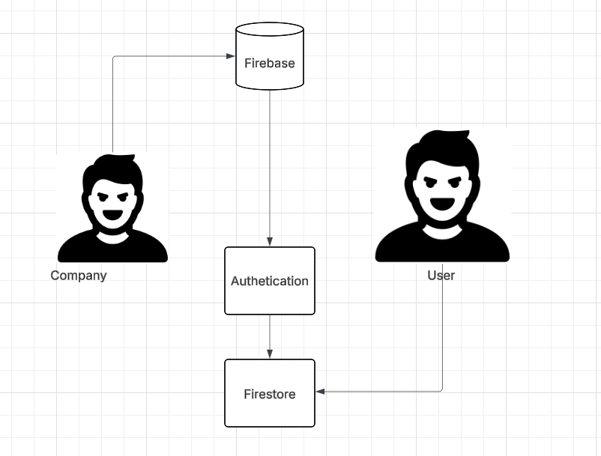

## 2.2 Product Functionality and Screenshots

* **Screens implemented:**  
  **Login/Register Screen**: Users can register, log in, or reset passwords via Firebase Auth.
* **Map Screen**: Displays current location and nearby collectors, powered by Google Maps.
* **Pickup Scheduling Screen**: Users select date, time, and waste type for collection.
* **Recyclables Marketplace**: Allows posting, browsing, and contacting for item exchange.
* **Payment Screen**: Interface to simulate mobile money transactions and display history.

Each screen is responsive, tested on both Android and web, and designed for minimal clicks.

**Login Screen Map screen**

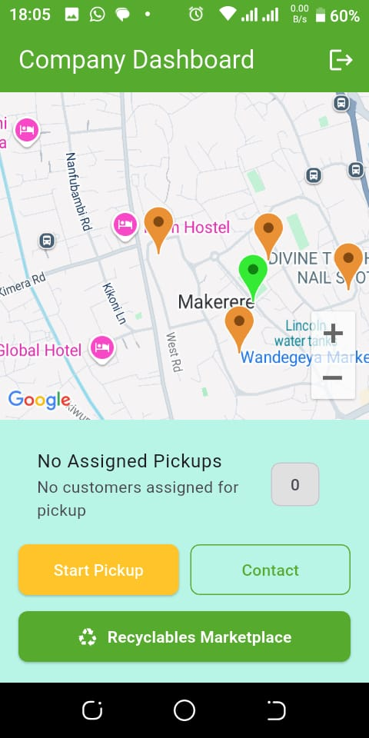 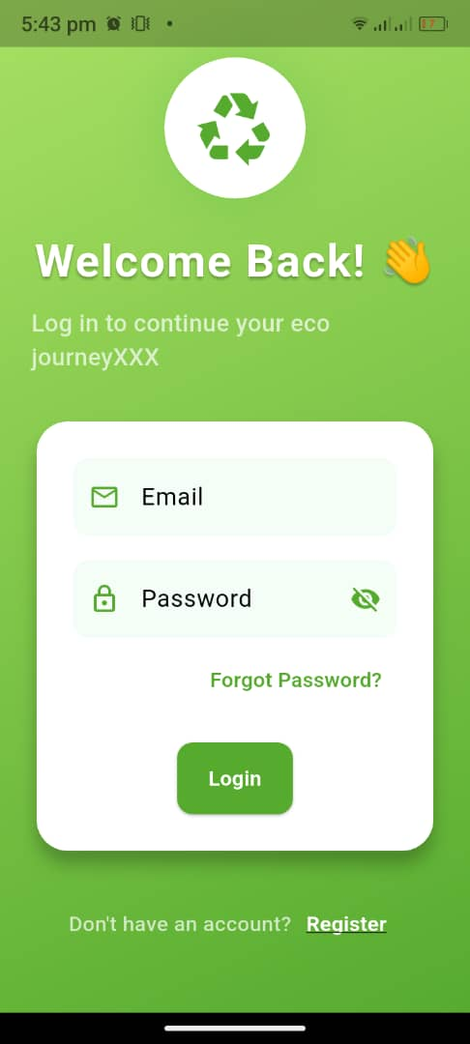

**Scheduling pickup Recyclables**

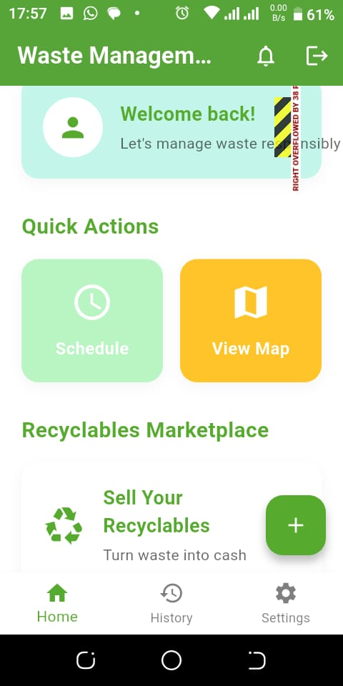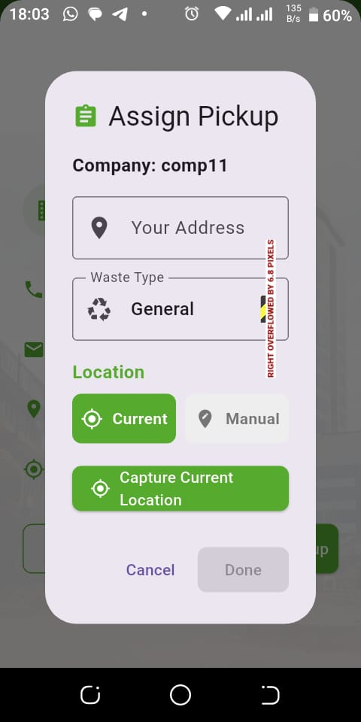

## 2.3 Project Website and Repository

- Repository: <https://github.com/Mackle10/group26-recces-.git>

- Website: <https://aesthetic-quokka-a84a57.netlify.app/>

App :

The website serves as the project's landing page with information, our services, the contact us page and team details. It also links to the different communication media for technical viewers.

# 3.0 Limitations and Next Steps

## 3.1 Limitations

* The mobile money payment is currently a simulation; real payment APIs like Flutter wave or Uganda’s Open API haven’t been integrated yet.
* App requires stable internet access and lacks offline capability or data caching.
* Notifications are generalized and cannot be customized per user preference.
* Marketplace lacks advanced filters such as distance, price range, and material purity.

.

## 3.2 Next Steps

* Integrate real mobile payment APIs for MTN and Airtel.
* Enable offline data entry and background sync when online.
* Expand marketplace to support better sorting and search options.
* Launch a digital points-based reward system to motivate regular use.
* Add AI image recognition for identifying recyclables using photos.
* Implement user rating and feedback for collectors and sellers.

# References

1. IEEE Editorial Style Manual, *IEEE Citation Reference*, IEEE, 2018. [Online]. <http://www.ieee.org/documents/ieeecitationref.pdf>
2. Google. (n.d.). *Google Maps Platform documentation*. Google Developers. <https://developers.google.com/maps/documentation/Google>,
3. "Firebase Documentation," Firebase. <https://firebase.google.com/docs>
4. Google. (n.d.). *Flutter documentation*. Flutter. <https://docs.flutter.dev/>

# Project Work Flow Diagram

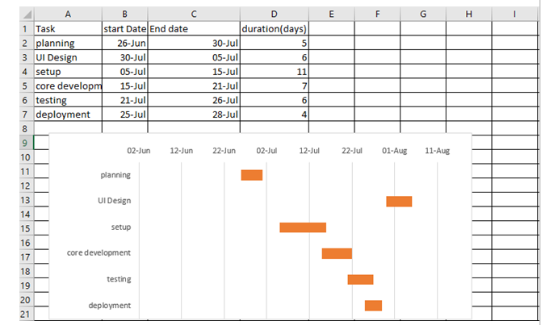

**Appendix B: Contribution for the Members**

|  |  |
| --- | --- |
| Team Member | Contribution |
| Mwizerwa Timothy | Overall project planning and task allocation  - worked on progress of the app  Codebase (Initial firmware Logic)  -Firebase (code modification) and API integration  Continuous app testing |
| Muwando Mark Alvin | -GitHub control (repository structure)  Worked jointly with Prudence on Progress of the Website  -Created the project poster  -continuous app testing  Weekly, Daily and monthly Reports on app progress |
| Wamukolo Timothy Ramon | -project idea  -jointly worked with Prudence on the final report  -continuous app testing |
| Atwijukire Anna Prudence | -Diagram construction  -website creation  Website Integrations with netlify  UI creation  -website control and error handling  -continuous app testing |